

Photo Credit: The Dallas Morning News (Tom Fox/ Staff Photographer)

Austin Crime Clearance Rates

By: Pender Fitzgerald, Matilda Soric, and Leticia Rinaldini

The city of Austin has seen quite a bit of growth over the past decade, and with large growth comes large problems. Besides the bustling traffic, price inflation and overflowing population, Austin has also faced growing crime rates as it continues to move towards becoming a traditional big city. Our group decided to analyze the crime trends from 2016 to get a better understanding of crime in Austin. Specifically, we analyzed the clearance rates of crimes while considering several factors. Our goal for this project was to find plausible and affordable solutions to increase the clearance rate of crimes in Austin.

Our group started off with a [data file](https://drive.google.com/file/d/16Xwtnvc3dCX_MEEAps9iE8D_ZErVV2rz/view?usp=sharing) of about 7.3MB consisting of nearly 37,500 rows of data. The data included information such as the type of crime as defined by the Austin Police Department as well as the FBI, location of the crime, date of the crime, the clearance date and the clearance status of each crime reported. We cleaned our data using Python and were left with nearly 35,000 rows of usable data to work with. Our work was completed primarily using Jupyter Notebooks, and you can find our work in its entirety posted on GitHub.(<-- github link)

As previously mentioned, we focused on the successful clearance rate of the crimes and ways to improve that rate. We looked at how factors like location, type of crime, and date of crime had an effect on the clearance rate. To begin, we looked at the overall trends for clearance rates. We found that out of 34,884 reported crimes, 84% were *not cleared*. For the crimes left over, 2% were still open cases, and only 14% were actually *cleared*.

Next, we looked at the types of crimes that were occurring. These types can be split into either FBI descriptions or APD descriptions. There were fewer unique FBI descriptions, which made the data easier to organize, so we mainly worked with these when considering types of crime. We found that theft made up a majority of the crimes, accounting for 71% of the data. Figure 1 shows that the most severe crime, murder, was the crime with the highest clearance rate. This could be attributed to the severity of the crime and the attention it receives. However, theft, being the most prominent crime in the data, was the crime with the lowest clearance rate. This could be due to the much larger number of thefts reported versus that of murder, which had an extremely low count (0.1% of the overall data). It could also be due to the fact that thefts are generally much harder to solve and are usually not a crime that the police department prioritizes. Aggravated assault had the second highest clearance rate, which we again believe has to do with the severity of the crime.

*Figure 1*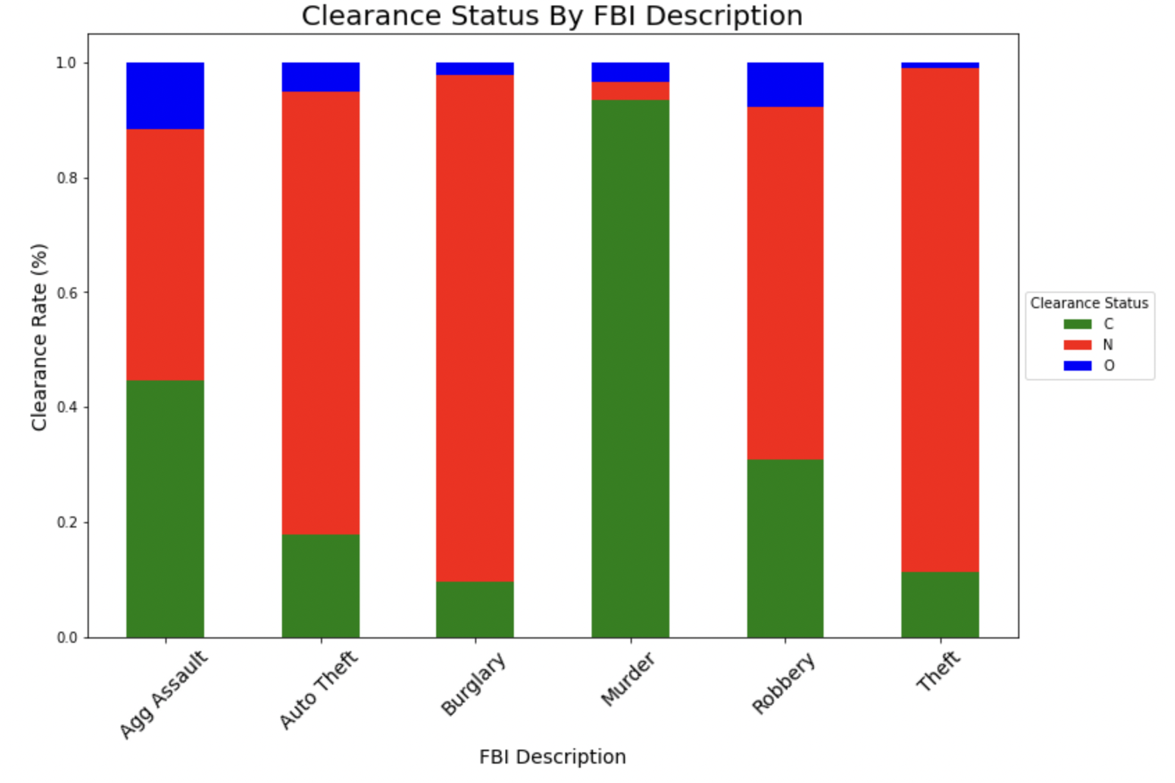

Next, we wanted to analyze the effects of location on the clearance rates of the crime. The greater Austin area has 46 unique zip codes in which these crimes took place. We decided to mainly focus on the ten zip codes with the highest amount of crime (Figure 2) and ten lowest amount of crimes (Figure 3). As seen in Figure 2, the zip codes 78753 (I-35 & W. Braker Ln) and 78741 (E. Riverside) had the highest clearance rates. These two zip codes also had the most crimes in the data, with thousands of thefts reported in each. The combination of the top ten zip codes accounts for 60% of the murders and a majority of the aggravated assaults as well. Having the most crimes, as well as the most severe crimes may be why the clearance rates are so much higher in these zip codes than those with lower amounts of crime. In the graph displaying the ten lowest zip codes (Figure 3) we can see that there is a much lower clearance rate than in those with more crimes. The crimes that occurred in the lower zip codes were also significantly less severe crimes with a majority of them being thefts. This supports our claim that less severe crimes have less of a chance of being cleared.

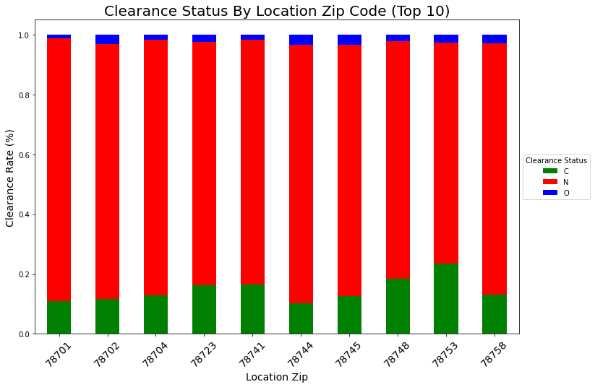

*Figure 2*

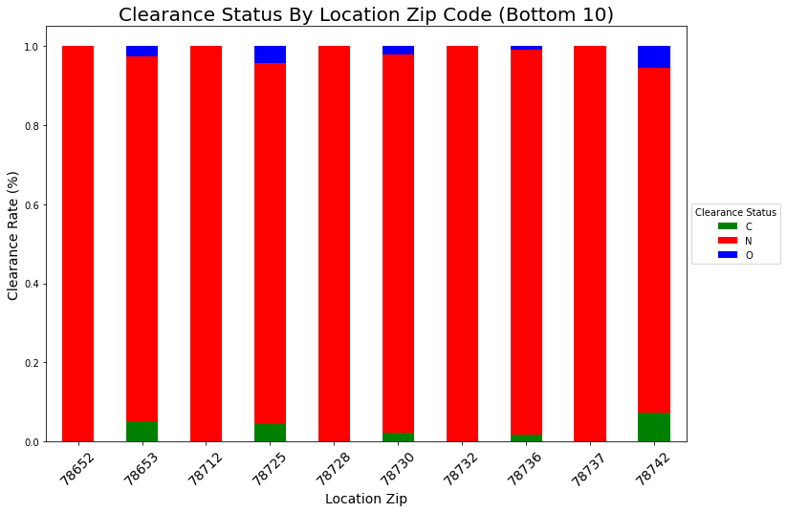

*Figure 3*

Here, we used a map retrieved from weloveaustin.com to highlight the locations of the lowest and highest zip codes. We can see in Figure 4 that the higher crime rates are mostly in the downtown and South Austin areas, which are heavily populated with dense amounts of tourists. The lower crime rates are in the suburban and less populated areas of the city.

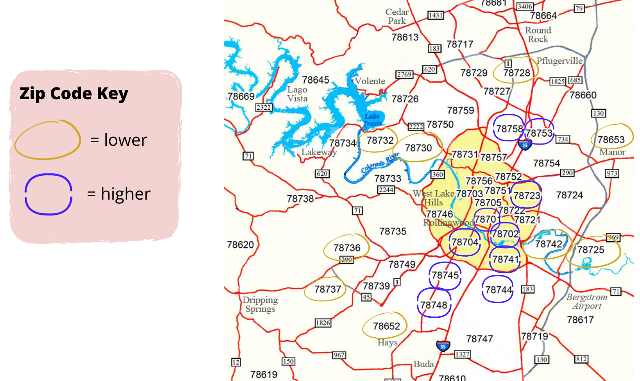

*Figure 4*

The final factor that we analyzed was the time of year that each crime occurred. In Figure 5 we observed that November and January had the largest amounts of non-cleared crimes. We came to the conclusion that the holiday season brings with it increased crime counts and lower clearance rates. August also had a high percentage of crimes not cleared coupled with a high number of crimes, which coincides with the timeframe of students returning to school. Also, the population increases during these months with heavy tourism. An oddity in our data, as seen in Figures 5 & 6, was April having a high crime count, but also having the highest clearance rate of any month in the data. This seems to go against the general trend in our data of high amounts of crime leading to low clearance rates. April’s high clearance rate could be explained by the elevated amount of violent crimes occurring during that time frame, which as we’ve mentioned previously, the APD seems to be very good at clearing.

*Figure 5*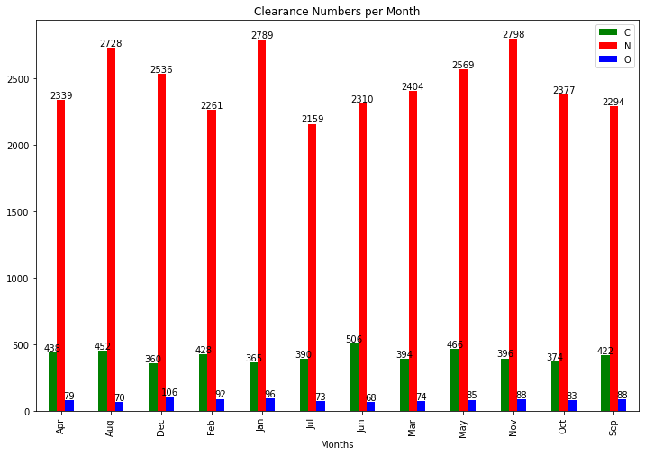

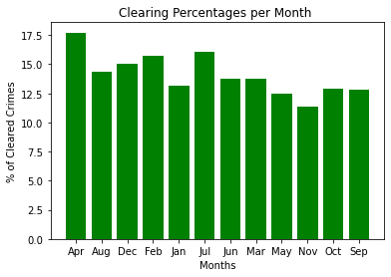

*Figure 6*

From our analysis, we were able to come up with some potential solutions to raise the clearance rate in Austin. As seen in figure 7, the highest reported crimes as defined by the Austin Police Department were various types of thefts and burglaries. Since this was the number one type of crime reported and also the least cleared, we conjured up several ideas to increase the clearance rate of non-violent crimes. To begin, increasing the amount of signage in non-gated parking lots and garages to remind people to lock up their belongings, particularly in the zip codes with higher amounts of thefts, could help to prevent car burglaries and grand theft. Also, adding more gates as well as cameras in areas that have a lot of theft crimes could be a potential solution. As for the home burglaries and general thefts, an affordable and easy solution would be to educate residents on the importance of having security systems on their vehicles and homes. This could not only prevent thefts, but could also serve as a way to catch perpetrators if a crime occurs. We also suggest increasing police patrol in high crime zip codes. This will increase vigilance and reduce the number of smaller crimes that remain not cleared from happening. The final suggestion we developed would be for officers to focus their efforts during the winter holidays when crime clearance rates are particularly low. Just like with any job, it is more difficult to get staff during these times, so potentially offering incentives to officers willing to patrol during those busy times could improve clearance rates and reduce the crime rate in general.

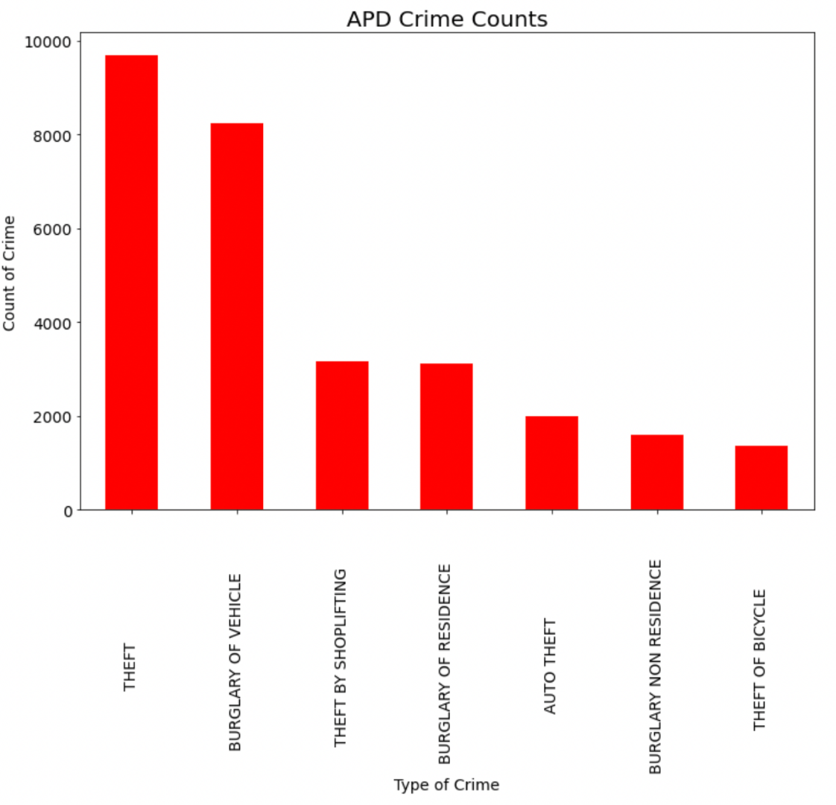

*Figure 7*